COURIER MANAGEMENT SYSTEM
A Project Report
Submitted in partial fulfilment of the requirements for the award of the degree of
[III Year/ BCA]
Submitted by
ABINAYA S
REKHA S
VITHIYA SRI S
LAKSHMI S
MAHALAKSHMI S

[E.S Arts and Science College (Co-Ed) ,Villupuram]
(ANNAMALAI UNIVERSITY )

2025 - 2026

ABSTRACT
The Courier Management System (CMS) is a software application designed to automate and streamline the day-to-day operations of a courier service company. Traditionally, courier companies manage bookings, parcel tracking, delivery status and billing through manual, paper-based registers, which are time-consuming, error-prone and difficult to scale as business volume grows. This project proposes a computerised system that allows staff to register customer parcels, generate a unique tracking number, assign delivery agents, update delivery status in real time, and generate invoices and reports.
The system is built with a relational database at its core and a simple, user-friendly interface for administrators, staff and customers. The primary objective is to reduce manual effort, minimise errors, improve transparency of parcel status, and provide faster and more reliable service to customers. The application is designed around a three-tier architecture that separates the presentation layer, business logic layer and data layer, making the system modular, maintainable and easy to extend.
This report documents the complete life cycle of the project - the existing manual system and its limitations, the proposed system and its advantages, a feasibility study covering technical, economic and operational dimensions, detailed requirement analysis, system design (including data flow diagrams, entity-relationship model and use case diagram), database design, module-wise description, sample implementation code, a structured testing plan with test cases, security considerations, cost estimation, and the scope for future enhancement. The Courier Management System, as designed, is intended to serve as a scalable foundation that can be adapted to real-world courier and logistics operations of varying sizes.
Keywords: Courier Management, Parcel Tracking, Logistics Automation, Relational Database, Web-Based Application, Billing and Invoicing, MIS Reporting.

TABLE OF CONTENTS
Certificate i
Declaration ii
Acknowledgement iii
Abstract iv
List of Figures v
List of Tables vi
1. Introduction 1
1.1 Purpose of the Project 1
1.2 Scope of the Project 2
1.3 Objectives of the Project 2
1.4 Organisation of the Report 3
2. Existing System 4
2.1 Overview of the Existing System 4
2.2 Limitations of the Existing System 5
3. Proposed System 6
3.1 Overview of the Proposed System 6
3.2 Advantages of the Proposed System 7
3.3 Comparison: Existing vs Proposed System 7
4. Feasibility Study 8
4.1 Technical Feasibility 8
4.2 Economic Feasibility 9
4.3 Operational Feasibility 9
4.4 Legal Feasibility 10
4.5 Schedule Feasibility 10
5. System Requirements 11
5.1 Hardware Requirements 11
5.2 Software Requirements 11
5.3 Functional Requirements 12
5.4 Non-Functional Requirements 13
6. System Design 14
6.1 System Architecture 14
6.2 Data Flow Diagram - Level 0 16
6.3 Data Flow Diagram - Level 1 17
6.4 Entity-Relationship Model 18
6.5 Use Case Diagram 19
6.6 Class Design Overview 20
7. Database Design 21
8. Module Description 27
9. System Implementation 32
10. Screenshots (Illustrative Wireframes) 36
11. Testing 38
12. System Security 41
13. Cost Estimation 42
14. Future Enhancements 43
15. Conclusion 44
16. Bibliography / References 45
Appendix A: Sample Source Code 46
Appendix B: Sample Test Data 49

LIST OF FIGURES
Figure 6.1: System Architecture Diagram 15
Figure 6.2: Data Flow Diagram - Level 0 (Context Diagram) 16
Figure 6.3: Data Flow Diagram - Level 1 17
Figure 6.4: Entity-Relationship Diagram 18
Figure 6.5: Use Case Diagram 19
Figure 10.1 - 10.6: Screen Wireframes 36

LIST OF TABLES
Table 5.1: Hardware Requirements 11
Table 5.2: Software Requirements 11
Table 5.3: Functional Requirements 12
Table 7.1 - 7.8: Database Tables 21
Table 11.1: Test Case Summary 39
Table 13.1: Effort and Cost Estimation 42

1. INTRODUCTION
Courier and logistics services form a critical part of trade and communication in the modern world. With the rise of e-commerce and inter-city trade, the volume of parcels handled by courier companies has grown rapidly over the last decade. Customers today expect not just delivery, but visibility - the ability to know exactly where their parcel is at any given moment, and when it will arrive. Managing this volume and this expectation manually leads to lost records, delayed deliveries, incorrect billing and a generally poor customer experience.
The Courier Management System (CMS) is developed to address these issues by digitising the entire parcel lifecycle - from booking to delivery. The system maintains records of customers, parcels, delivery agents, branches and payments in a centralised database, allowing quick retrieval of information and real-time tracking of any parcel using a unique tracking ID. By replacing manual registers with a structured database-backed application, the system aims to bring the same level of reliability and transparency that customers have come to expect from large, organised logistics providers, but in a form that is simple enough to be adopted by a small or medium-sized courier business.

1.1 Purpose of the Project
The purpose of this project is to design and develop a computerised system that automates the core operations of a courier company. Specifically, the project aims:
- To automate parcel booking, tracking and delivery management, removing dependence on paper registers.
- To reduce paperwork and the manual record-keeping errors that come with it.
- To provide real-time parcel status to both staff and customers through a unique tracking number.
- To generate accurate bills and invoices quickly and consistently, removing manual calculation errors.
- To improve overall operational efficiency and customer satisfaction through faster service.
- To provide management with quick access to reports (bookings, revenue, pending deliveries) for decision-making.

1.2 Scope of the Project
The system covers customer registration, parcel booking, tracking-number generation, delivery agent assignment, delivery status updates, billing and invoicing, and report generation (daily bookings, pending deliveries, revenue reports, and agent-wise performance). The system is designed to be used by three categories of users: administrators (who configure branches, agents and view reports), staff (who handle day-to-day booking and billing at a branch counter), and customers (who use their tracking number to check the status of their parcel).
The scope of this version of the system is limited to a single organisation operating across multiple branches. It does not, at this stage, integrate with third-party payment gateways, SMS gateways or GPS-tracking hardware, although the architecture has been designed so that these can be added later without a major redesign - this is discussed further in Chapter 14 (Future Enhancements). The system also assumes that the organisation already has a defined set of branches and delivery agents, and that these are onboarded into the system by the administrator during setup.

1.3 Objectives of the Project
The specific, measurable objectives that guided the design of this system are summarised below:
- Provide a single, centralised digital record for every customer, parcel, agent, branch and payment - eliminating duplicate and inconsistent paper records.
- Generate a unique, unambiguous tracking number for every parcel booked, following a predictable and collision-free format.
- Ensure that a parcel's status (Booked, Picked Up, In Transit, Out for Delivery, Delivered) is updated within the system as soon as an agent records the change, so that the information available to a customer is never more than a few minutes out of date.
- Calculate delivery charges consistently, based on a transparent formula involving weight and distance/zone, so that two customers with identical shipments are charged identically.
- Reduce the average time taken to book a parcel at the counter compared to the manual process.
- Provide the administrator with on-demand reports rather than reports that must be manually compiled at the end of each day or month.

1.4 Organisation of the Report
The remainder of this report is organised as follows. Chapter 2 describes the existing manual system and its limitations. Chapter 3 introduces the proposed system and its advantages over the existing process. Chapter 4 presents a feasibility study covering technical, economic, operational, legal and schedule dimensions. Chapter 5 lists the hardware and software requirements along with functional and non-functional requirements. Chapter 6 covers system design, including the system architecture, data flow diagrams, entity-relationship model and use case diagram. Chapter 7 presents the detailed database design. Chapter 8 describes each functional module of the system. Chapter 9 discusses system implementation with representative code snippets. Chapter 10 presents illustrative screen wireframes. Chapter 11 documents the testing strategy and test cases. Chapter 12 discusses system security. Chapter 13 presents a cost estimation. Chapter 14 discusses future enhancements, and Chapter 15 concludes the report. The report closes with a bibliography and two appendices containing sample source code and sample test data.

2. EXISTING SYSTEM

2.1 Overview of the Existing System
In the existing manual system, courier bookings are recorded in physical registers or, at best, in basic, disconnected spreadsheets maintained independently at each branch. When a customer brings a parcel to the counter, a staff member manually writes down the sender and receiver details, weighs the parcel, calculates the charge using a printed rate card, and hands the customer a hand-written or a very basic printed receipt. There is no single system tying together the branches, so the head office typically has no live visibility into how many parcels are in the system at any given time.
Once a parcel leaves the branch, its status is tracked informally - usually through phone calls between branches or between staff and delivery agents. Customers have no way of tracking their parcel except by calling the branch office and waiting for someone to manually look through logs or call the agent directly. Billing is calculated manually using a printed rate card and a calculator, which is time-consuming and prone to mistakes, especially during busy periods. Searching for a particular parcel's status requires going through paper records chronologically, and generating summary reports (e.g., monthly revenue, number of pending deliveries) is a tedious, manual, end-of-day or end-of-month task performed by tallying entries by hand.

2.2 Limitations of the Existing System
Based on the process described above, the following limitations were identified in the existing manual system:
- No centralised record of parcels and customers - each branch maintains its own isolated records.
- High chance of human error in billing (wrong weight slab, wrong zone) and in data entry (illegible handwriting, transposed digits in phone numbers).
- No real-time tracking facility for customers; status information is at least as stale as the last phone call between branches.
- Difficult and slow report generation, since reports must be manually compiled from paper registers.
- Risk of loss, damage or misplacement of paper records, with no backup copy.
- Poor scalability - as the business grows and parcel volume increases, the manual process becomes proportionally slower and more error-prone, rather than scaling efficiently.
- No historical analytics - it is very difficult to answer questions like “which branch had the most bookings last month” or “which agent has the best on-time delivery rate” without extensive manual effort.
- Inconsistent customer experience - the quality of service depends heavily on which staff member handles a booking or a query, since there is no standard, system-enforced process.

3. PROPOSED SYSTEM

3.1 Overview of the Proposed System
The proposed Courier Management System is a computerised application backed by a relational database. It automates parcel registration, generates a unique tracking number for every booking, allows delivery agents' status updates to be recorded directly into the system, and lets customers check delivery status themselves using their tracking number, without needing to call the branch. Administrators can view dashboards and generate reports on bookings, revenue and pending deliveries at the click of a button, across all branches, rather than just the branch they happen to be at.
The system is designed around a three-tier architecture (described in detail in Chapter 6), which cleanly separates the user interface from the business rules and from the underlying data storage. This separation makes the system easier to maintain, test and extend - for instance, a new report can be added to the reporting module without needing to change how bookings are recorded, and the interface used by customers can be redesigned without touching the underlying billing logic.

3.2 Advantages of the Proposed System
- Centralised, accurate and secure storage of all records across every branch of the organisation.
- Real-time parcel tracking for customers and staff, updated the moment an agent records a status change.
- Automatic bill and invoice generation, removing manual calculation and the errors that come with it.
- Fast search and retrieval of customer and parcel information using the tracking number, phone number or customer name.
- Reduced manual workload for staff, freeing time for direct customer service.
- Easy generation of MIS (Management Information System) reports for management decision-making, available on demand rather than compiled by hand.
- A single source of truth for parcel status, so that every branch and every staff member sees the same, up-to-date information.
- A foundation that can be extended with SMS notifications, online payments, GPS tracking and a mobile app, as discussed in Chapter 14.

3.3 Comparison: Existing vs Proposed System
Aspect | Existing (Manual) System | Proposed (Computerised) System
Record keeping | Paper registers / isolated spreadsheets per branch | Centralised relational database shared across branches
Tracking number | None, or informally assigned | System-generated, unique and searchable
Status updates | Phone calls between branches/agents | Recorded directly by the agent into the system, visible instantly
Billing | Manual calculation using printed rate card | Automatic calculation based on weight/zone rules
Customer tracking | Not available; customer must call branch | Self-service tracking using tracking number
Reports | Manually compiled, end of day/month | Generated on demand, real time
Error rate | Relatively high (manual entry & calculation) | Reduced through validation and automated calculation
Scalability | Degrades as volume grows | Scales with additional branches/agents/records

4. FEASIBILITY STUDY
Before finalising the design of the Courier Management System, a feasibility study was carried out to determine whether the project was worth pursuing from technical, economic, operational, legal and scheduling standpoints. The findings of this study are summarised below.

4.1 Technical Feasibility
Technical feasibility examines whether the proposed system can be built with the technology, tools and skills available. The Courier Management System relies on well-established, mature technologies - a relational database management system (such as MySQL), a standard web or desktop front-end framework, and a widely used back-end programming language. None of these components require experimental or cutting-edge technology; all of them are documented extensively and are commonly taught as part of standard computer science and information technology curricula. The hardware requirements (Section 5.1) are modest and can be met by any standard desktop or laptop computer, and no specialised hardware (barcode scanners, GPS trackers, etc.) is required for the core version of the system described in this report. The project is therefore considered technically feasible.

4.2 Economic Feasibility
Economic feasibility examines whether the benefits of the system justify its cost. The system is built primarily using free and open-source software - the database engine, the programming language/runtime, and the IDE are all available at no licensing cost, which keeps the development cost of the project largely limited to development time/effort rather than software licensing. On the benefit side, the system is expected to reduce the staff-hours spent on manual billing calculations and report compilation, reduce revenue leakage from billing errors, and reduce the cost of customer-service phone calls that currently exist purely to answer “where is my parcel” queries. A detailed cost estimation using a simplified effort-based model is presented in Chapter 13; based on that estimate, the system is considered economically feasible, particularly for an organisation of even a moderate parcel volume.

4.3 Operational Feasibility
Operational feasibility examines whether the proposed system will actually be used effectively once deployed, given the skills of the people who will operate it. Because the interface is designed to closely mirror the existing manual workflow (a booking counter screen that mirrors the fields on the old paper form, for instance), the learning curve for existing staff is expected to be short. The system does not require staff to have any programming knowledge; it requires only basic computer literacy (typing, using a mouse, navigating simple forms), which is a reasonable assumption for front-desk staff in the present day. Delivery agents are expected to interact with a very small, focused screen (select parcel, select new status, submit), which further reduces the training burden. The system is therefore considered operationally feasible.

4.4 Legal Feasibility
Legal feasibility examines whether the system complies with applicable laws and regulations, particularly around data handling. The system stores personal information belonging to customers (name, address, phone number, email) and, to a lesser extent, delivery agents. The design assumes that access to this data is restricted by role (only authorised staff and administrators can view customer records; customers can only view the status of their own parcel using their tracking number) and that the organisation deploying the system will apply this in accordance with applicable data protection regulations in its jurisdiction. All third-party software used (database engine, programming language, libraries) is assumed to be used under its respective open-source or properly licensed terms.

4.5 Schedule Feasibility
Schedule feasibility examines whether the project can be completed within the time available - which, for an academic project, is typically one semester. The modular nature of the system (booking, tracking, billing and reporting as largely independent modules built on a common database) allows development to proceed incrementally: the database schema and booking module can be built and tested first, followed by the tracking and billing modules, and finally the reporting module and any polish/testing pass. This incremental approach is well suited to a fixed academic timeline and reduces the risk of the entire project stalling on a single difficult component.

5. SYSTEM REQUIREMENTS

5.1 Hardware Requirements
Component | Specification
Processor | Intel i3 / AMD equivalent or above
RAM | 4 GB minimum (8 GB recommended)
Hard Disk | 250 GB or above
Monitor | Standard colour monitor
Other | Keyboard, mouse, internet connection (for web-based deployment)

5.2 Software Requirements
Component | Specification
Operating System | Windows 10 / 11, Linux or macOS
Front-End | HTML, CSS, JavaScript / Java Swing / any GUI framework
Back-End Language | Java / Python / PHP / C# (chosen based on curriculum; PHP is used for the illustrative code in this report)
Database | MySQL / Oracle / SQL Server
IDE | VS Code / Eclipse / NetBeans
Other Tools | XAMPP / WAMP (if web-based), Git for version control

5.3 Functional Requirements
Functional requirements describe what the system must do. They are summarised in the table below, grouped by module.
ID | Requirement
FR-1 | The system shall allow staff to register a new customer with name, address, phone and email.
FR-2 | The system shall allow staff to book a parcel against an existing or newly registered customer.
FR-3 | The system shall automatically generate a unique tracking number for every parcel booked.
FR-4 | The system shall allow an administrator to assign a delivery agent and branch to a parcel.
FR-5 | The system shall allow a delivery agent to update the status of a parcel (Booked, Picked Up, In Transit, Out for Delivery, Delivered).
FR-6 | The system shall allow a customer to view the current status of a parcel using its tracking number, without logging in.
FR-7 | The system shall calculate the delivery charge automatically based on parcel weight and destination zone.
FR-8 | The system shall generate a printable invoice/receipt for every booking.
FR-9 | The system shall record the payment mode and payment date for every booking.
FR-10 | The system shall allow an administrator to generate a daily booking summary report.
FR-11 | The system shall allow an administrator to generate a pending-deliveries report.
FR-12 | The system shall allow an administrator to generate a monthly revenue report.
FR-13 | The system shall allow an administrator to generate an agent-wise performance report.
FR-14 | The system shall allow an administrator to manage (add/update/deactivate) branches and delivery agents.
FR-15 | The system shall validate all mandatory input fields before saving a record.

5.4 Non-Functional Requirements
Non-functional requirements describe how the system should perform, rather than what it should do. The following non-functional requirements apply to the Courier Management System:
- Performance: A tracking-number lookup should return a result within 2 seconds under normal load.
- Usability: Staff with basic computer literacy should be able to book a parcel after no more than 30 minutes of training.
- Reliability: The system should be available during business hours with minimal unplanned downtime; database backups should be taken at least once per day.
- Scalability: The database schema should support a growing number of branches, agents and parcels without requiring structural changes.
- Security: Access to customer, billing and administrative functions should be restricted by role-based login; customers should only be able to view (not edit) status information.
- Maintainability: The three-tier architecture should allow individual modules (booking, tracking, billing, reporting) to be modified independently.
- Portability: The system should run on any operating system that supports the chosen back-end language and database engine.

6. SYSTEM DESIGN
System design translates the requirements gathered in Chapter 5 into a blueprint for building the software. This chapter describes the system architecture, the data flow through the system at two levels of detail, the entity-relationship model that underlies the database, a use case diagram summarising user interactions, and an overview of the major classes that would form the application layer.

6.1 System Architecture
The system follows a three-tier architecture consisting of the Presentation Layer (the user interface presented to Admin, Staff and Customer users), the Application / Business Logic Layer (which handles booking validation, tracking-ID generation, and billing calculations), and the Data Layer (the relational database that stores all persistent records). Separating these layers means that changes to the user interface do not require changes to the business rules, and changes to the business rules do not require changes to how data is physically stored.
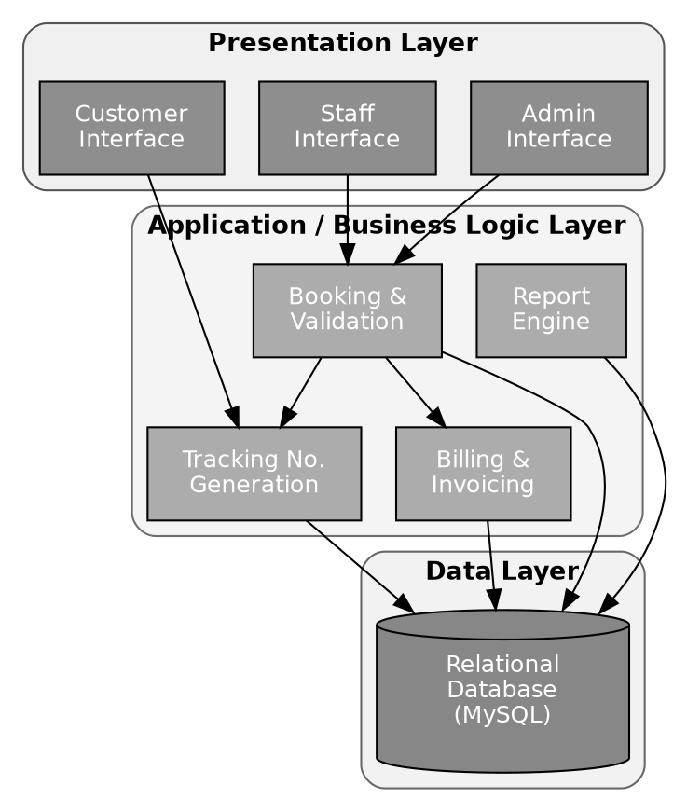
Figure 6.1: System Architecture Diagram
In this architecture, the Presentation Layer exposes three distinct interfaces tailored to each user role: an Admin interface for configuration and reporting, a Staff interface for booking and billing, and a Customer interface limited to tracking lookups. All three interfaces communicate exclusively with the Application Layer, never directly with the database - this ensures that business rules (such as how a tracking number is generated, or how a bill is calculated) are enforced consistently regardless of which interface initiated the request. The Application Layer, in turn, is the only layer that reads from and writes to the Data Layer.

6.2 Data Flow Diagram - Level 0 (Context Diagram)
The Level 0 Data Flow Diagram (also called the context diagram) treats the entire Courier Management System as a single process and shows how it interacts with its external entities: Customer, Staff, Delivery Agent and Admin.
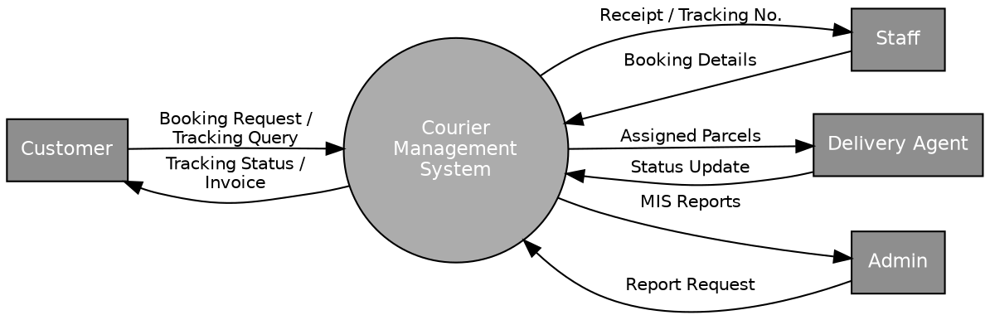
Figure 6.2: Data Flow Diagram - Level 0 (Context Diagram)
As shown in Figure 6.2, the Customer sends a booking request or a tracking query to the system and receives back a tracking status or an invoice. Staff send booking details to the system and receive a receipt containing the tracking number. Delivery agents send status updates and receive the list of parcels assigned to them. The Admin sends report requests and receives MIS reports in return.

6.3 Data Flow Diagram - Level 1
The Level 1 DFD expands the single process shown in Figure 6.2 into its five major sub-processes - Booking, Tracking Number Generation, Status Update, Billing and Reporting - along with the data stores each of them reads from or writes to.
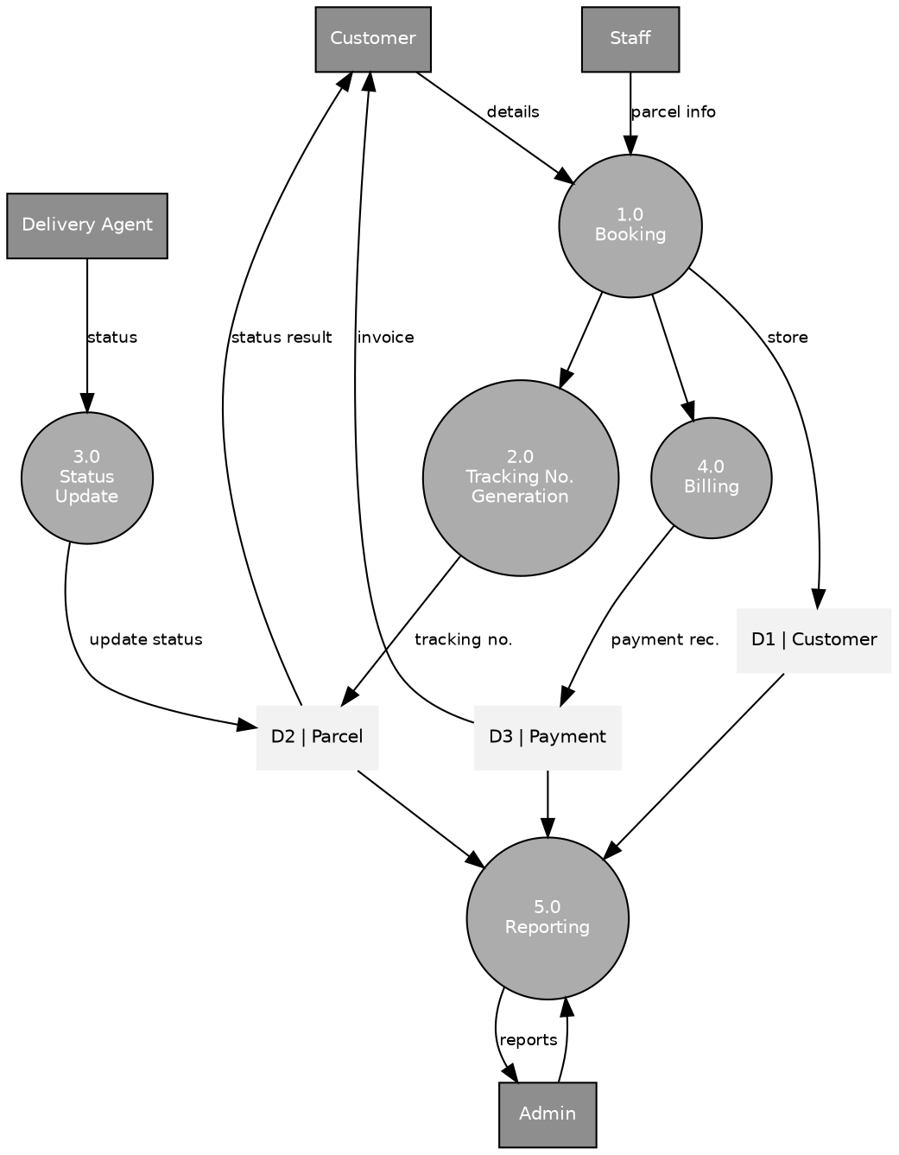
Figure 6.3: Data Flow Diagram - Level 1
Process 1.0 (Booking) receives customer and parcel details from Staff and the Customer, validates them, and stores them in the Customer and Parcel data stores. It then triggers Process 2.0 (Tracking Number Generation), which writes the newly generated tracking number back into the Parcel data store, and Process 4.0 (Billing), which calculates the charge and writes a record into the Payment data store. Process 3.0 (Status Update) is triggered by the Delivery Agent and updates the Status field of the relevant Parcel record, which is what the Customer's tracking query ultimately reads. Process 5.0 (Reporting) is triggered by the Admin and reads across all three data stores to produce the requested report.

6.4 Entity-Relationship Model
The database is designed around five major entities and their relationships: a Customer can book many Parcels; a Branch has many Delivery Agents and many Parcels processed through it; a Delivery Agent handles many Parcels; and each Parcel booking has exactly one associated Payment record.
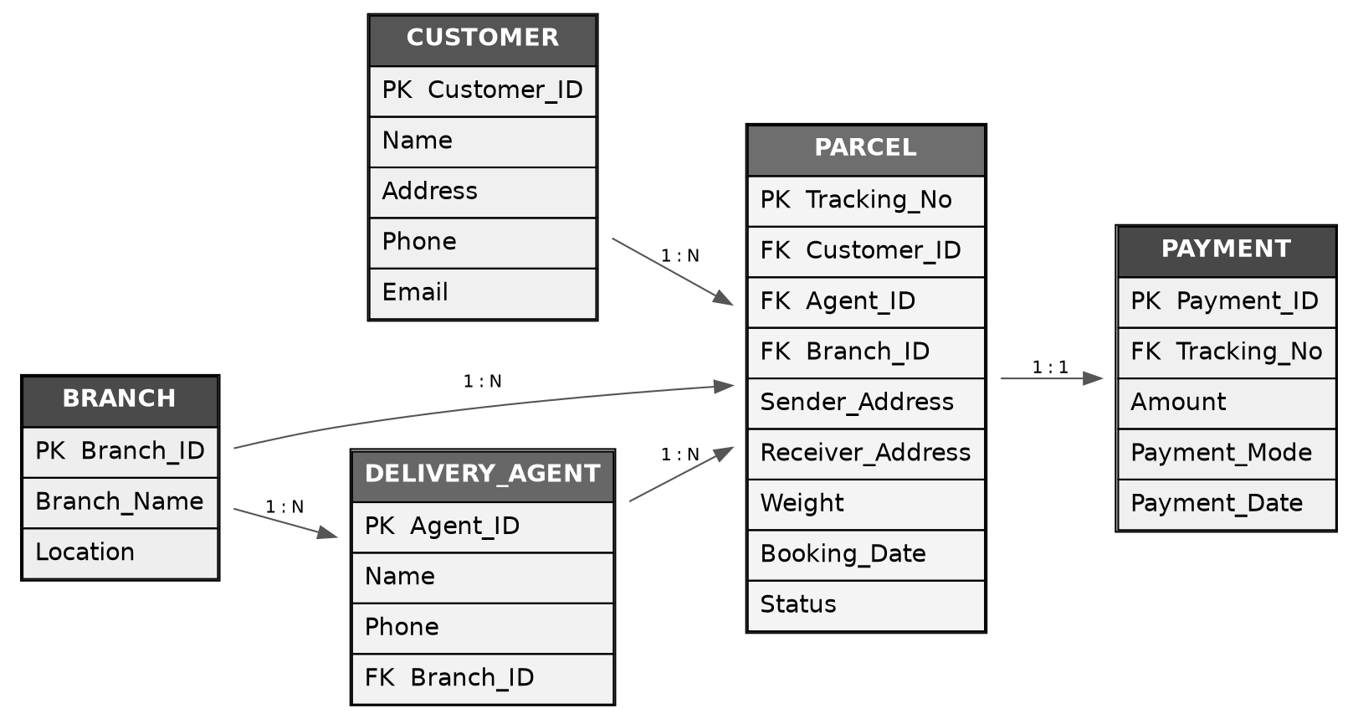
Figure 6.4: Entity-Relationship Diagram
The cardinalities shown in Figure 6.4 directly inform the foreign-key structure of the database tables described in Chapter 7: the Parcel table carries foreign keys to Customer, Delivery_Agent and Branch, while the Payment table carries a foreign key back to Parcel.

6.5 Use Case Diagram
The use case diagram in Figure 6.5 summarises the interactions between the four actors of the system (Admin, Staff, Delivery Agent, Customer) and the major functions of the Courier Management System.
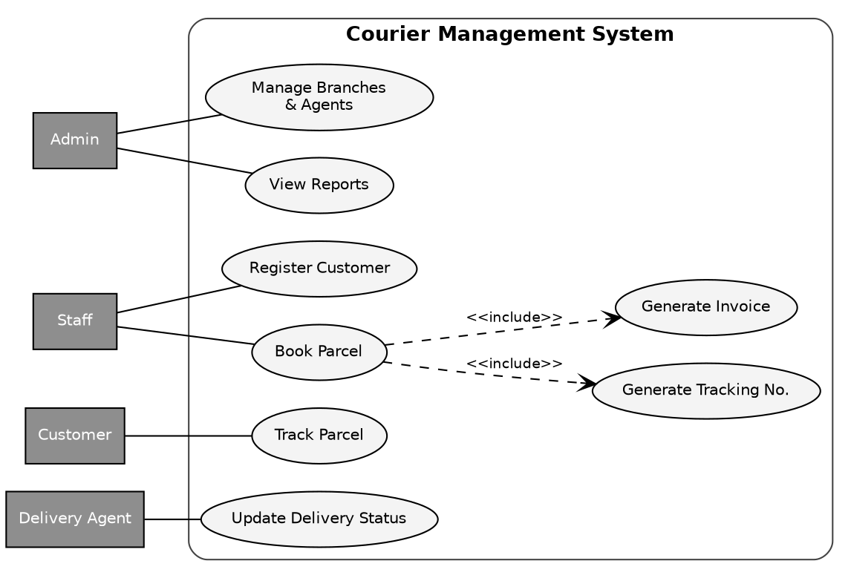
Figure 6.5: Use Case Diagram
Two include relationships are shown: booking a parcel always includes generating a tracking number and generating an invoice, since these two actions are an inseparable part of the booking transaction rather than something a staff member triggers separately.

6.6 Class Design Overview
Although the exact class structure will depend on the implementation language chosen, the application layer is expected to be organised around the following core classes, which map closely to the entities identified in the ER model and the modules described in Chapter 8:
- Customer - holds customer attributes and provides methods to register and update customer details.
- Parcel - holds parcel attributes and status; provides methods to generate a tracking number and update status.
- DeliveryAgent - holds agent attributes; provides a method to list parcels currently assigned to the agent.
- Branch - holds branch attributes; provides a method to list agents and parcels associated with the branch.
- Payment - holds payment attributes; provides a method to calculate the amount due, given a parcel's weight and destination zone.
- BookingService - the central business-logic class that coordinates creating a Customer (if new), a Parcel, a tracking number and a Payment record as a single booking transaction.
- ReportService - queries the Customer, Parcel and Payment tables to produce the reports described in Section 5.3 (FR-10 to FR-13).
This class-level separation mirrors the module boundaries described in Chapter 8 and keeps each class responsible for a single, well-defined part of the system's behaviour, which is a widely recommended object-oriented design practice (the “single responsibility principle”).

7. DATABASE DESIGN
This chapter presents the detailed schema of the database that underlies the Courier Management System. Compared to the entity list introduced in Chapter 6, the schema here has been extended with three additional tables - Staff, Invoice and Notification - which are needed to support login-based access control, a formal invoice record separate from the raw payment record, and a log of status-change notifications respectively. Every table is presented with its fields, data types and a short description, followed by a discussion of the normalisation applied to the design.

7.1 Customer Table
Stores the personal and contact details of every customer who has booked at least one parcel.
Field | Data Type | Description
Customer_ID | INT (PK, AUTO_INCREMENT) | Unique customer identifier
Name | VARCHAR(50) | Customer's full name
Address | VARCHAR(150) | Customer's address
Phone | VARCHAR(15) | Contact number
Email | VARCHAR(50) | Email address
Created_At | TIMESTAMP | Date/time the customer record was created

7.2 Parcel Table
The central table of the system; every booking creates exactly one row here.
Field | Data Type | Description
Tracking_No | VARCHAR(20) (PK) | Unique tracking number, e.g. CMS-2026-000481
Customer_ID | INT (FK) | References Customer table
Agent_ID | INT (FK, NULLABLE) | References Delivery_Agent table; NULL until assigned
Branch_ID | INT (FK) | References Branch table
Sender_Address | VARCHAR(150) | Pickup address
Receiver_Address | VARCHAR(150) | Delivery address
Receiver_Name | VARCHAR(50) | Name of the recipient
Receiver_Phone | VARCHAR(15) | Recipient's contact number
Weight | DECIMAL(5,2) | Parcel weight in kg
Zone | VARCHAR(20) | Destination zone used for billing (Local / Regional / National)
Booking_Date | DATE | Date of booking
Expected_Delivery_Date | DATE | System-estimated delivery date
Status | VARCHAR(20) | Booked / Picked Up / In Transit / Out for Delivery / Delivered
Last_Updated | TIMESTAMP | Date/time the status was last changed

7.3 Delivery_Agent Table
Field | Data Type | Description
Agent_ID | INT (PK, AUTO_INCREMENT) | Unique agent identifier
Name | VARCHAR(50) | Agent's name
Phone | VARCHAR(15) | Contact number
Branch_ID | INT (FK) | References Branch table
Status | VARCHAR(15) | Active / Inactive
Parcels_Delivered | INT | Running count, used for agent-performance reporting

7.4 Branch Table
Field | Data Type | Description
Branch_ID | INT (PK, AUTO_INCREMENT) | Unique branch identifier
Branch_Name | VARCHAR(50) | Branch name
Location | VARCHAR(100) | Branch address / city
Contact_Phone | VARCHAR(15) | Branch contact number

7.5 Payment Table
Field | Data Type | Description
Payment_ID | INT (PK, AUTO_INCREMENT) | Unique payment identifier
Tracking_No | VARCHAR(20) (FK) | References Parcel table
Amount | DECIMAL(8,2) | Amount paid
Payment_Mode | VARCHAR(20) | Cash / Card / UPI / Online
Payment_Status | VARCHAR(15) | Paid / Pending
Payment_Date | DATE | Date of payment

7.6 Staff Table
Added to support role-based login for staff and administrator users of the system.
Field | Data Type | Description
Staff_ID | INT (PK, AUTO_INCREMENT) | Unique staff identifier
Name | VARCHAR(50) | Staff member's name
Username | VARCHAR(30) | Login username
Password_Hash | VARCHAR(255) | Hashed password (never stored in plain text)
Role | VARCHAR(15) | Admin / Staff
Branch_ID | INT (FK) | References Branch table

7.7 Invoice Table
Separated from the Payment table so that an invoice can be generated (and reprinted) independently of when payment is actually recorded.
Field | Data Type | Description
Invoice_No | VARCHAR(20) (PK) | Unique invoice number
Tracking_No | VARCHAR(20) (FK) | References Parcel table
Issued_Date | DATE | Date the invoice was generated
Subtotal | DECIMAL(8,2) | Charge before tax
Tax | DECIMAL(8,2) | Applicable tax amount
Total | DECIMAL(8,2) | Subtotal + Tax

7.8 Notification Table
Maintains a log of status-change events, providing the data needed for the future SMS/email notification enhancement discussed in Chapter 14.
Field | Data Type | Description
Notification_ID | INT (PK, AUTO_INCREMENT) | Unique notification identifier
Tracking_No | VARCHAR(20) (FK) | References Parcel table
Status_At_Event | VARCHAR(20) | Status value that triggered the notification
Event_Timestamp | TIMESTAMP | Date/time the status changed
Sent | BOOLEAN | Whether the notification has been dispatched

7.9 Normalisation
The schema above was designed to satisfy Third Normal Form (3NF), which eliminates redundant data and the update anomalies that come with it.

First Normal Form (1NF)
Every table has a primary key and every column holds a single, atomic value - for example, Receiver_Name and Receiver_Phone are stored as separate columns in the Parcel table rather than being combined into a single “Receiver Details” column, which would have made searching and validation difficult.

Second Normal Form (2NF)
Since every table in this design uses a single-column primary key (rather than a composite key), partial dependency does not arise, and 2NF is satisfied automatically once 1NF holds.

Third Normal Form (3NF)
No non-key column depends on another non-key column. For example, Branch_Name and Location are not repeated in the Parcel or Delivery_Agent tables; instead, those tables store only a Branch_ID foreign key, and the branch's descriptive details are looked up from the single row in the Branch table. This means that if a branch's location changes, only one row (in the Branch table) needs to be updated, rather than every Parcel and Delivery_Agent row that references it.
The separation of the Payment and Invoice tables described in Sections 7.5 and 7.7 is a deliberate design decision beyond strict normalisation requirements: it allows the system to represent a booking that has an invoice but no payment yet (i.e. “billed, awaiting payment”), which is a common real-world scenario, particularly for corporate customers on account-based billing.

7.10 Referential Integrity
Foreign-key constraints are used throughout the schema to enforce referential integrity at the database level, rather than relying solely on application-level checks. The relationships are summarised below:
- Parcel.Customer_ID references Customer.Customer_ID - ON DELETE RESTRICT (a customer with existing bookings cannot be deleted outright).
- Parcel.Agent_ID references Delivery_Agent.Agent_ID - ON DELETE SET NULL (if an agent record is removed, existing parcels simply become unassigned rather than being deleted).
- Parcel.Branch_ID references Branch.Branch_ID - ON DELETE RESTRICT.
- Delivery_Agent.Branch_ID references Branch.Branch_ID - ON DELETE RESTRICT.
- Payment.Tracking_No references Parcel.Tracking_No - ON DELETE CASCADE (deleting a parcel record removes its associated payment record).
- Invoice.Tracking_No references Parcel.Tracking_No - ON DELETE CASCADE.
- Notification.Tracking_No references Parcel.Tracking_No - ON DELETE CASCADE.

7.11 Sample Schema Definition (MySQL DDL)
An abridged version of the Data Definition Language (DDL) statements used to create the core tables is given below; the complete script also creates the Staff, Invoice and Notification tables described above, along with the necessary indexes on Tracking_No, Customer_ID and Phone to keep lookups fast as the volume of records grows.
CREATE TABLE Branch (
Branch_ID INT AUTO_INCREMENT PRIMARY KEY,
Branch_Name VARCHAR(50) NOT NULL,
Location VARCHAR(100) NOT NULL,
Contact_Phone VARCHAR(15)
);
CREATE TABLE Customer (
Customer_ID INT AUTO_INCREMENT PRIMARY KEY,
Name VARCHAR(50) NOT NULL,
Address VARCHAR(150),
Phone VARCHAR(15) NOT NULL,
Email VARCHAR(50),
Created_At TIMESTAMP DEFAULT CURRENT_TIMESTAMP
);
CREATE TABLE Delivery_Agent (
Agent_ID INT AUTO_INCREMENT PRIMARY KEY,
Name VARCHAR(50) NOT NULL,
Phone VARCHAR(15),
Branch_ID INT NOT NULL,
Status VARCHAR(15) DEFAULT 'Active',
Parcels_Delivered INT DEFAULT 0,
FOREIGN KEY (Branch_ID) REFERENCES Branch(Branch_ID)
);
CREATE TABLE Parcel (
Tracking_No VARCHAR(20) PRIMARY KEY,
Customer_ID INT NOT NULL,
Agent_ID INT NULL,
Branch_ID INT NOT NULL,
Sender_Address VARCHAR(150) NOT NULL,
Receiver_Address VARCHAR(150) NOT NULL,
Receiver_Name VARCHAR(50) NOT NULL,
Receiver_Phone VARCHAR(15),
Weight DECIMAL(5,2) NOT NULL,
Zone VARCHAR(20) NOT NULL,
Booking_Date DATE NOT NULL,
Expected_Delivery_Date DATE,
Status VARCHAR(20) DEFAULT 'Booked',
Last_Updated TIMESTAMP DEFAULT CURRENT_TIMESTAMP ON UPDATE CURRENT_TIMESTAMP,
FOREIGN KEY (Customer_ID) REFERENCES Customer(Customer_ID),
FOREIGN KEY (Agent_ID) REFERENCES Delivery_Agent(Agent_ID) ON DELETE SET NULL,
FOREIGN KEY (Branch_ID) REFERENCES Branch(Branch_ID)
);
CREATE TABLE Payment (
Payment_ID INT AUTO_INCREMENT PRIMARY KEY,
Tracking_No VARCHAR(20) NOT NULL,
Amount DECIMAL(8,2) NOT NULL,
Payment_Mode VARCHAR(20),
Payment_Status VARCHAR(15) DEFAULT 'Pending',
Payment_Date DATE,
FOREIGN KEY (Tracking_No) REFERENCES Parcel(Tracking_No) ON DELETE CASCADE
);
CREATE INDEX idx_parcel_customer ON Parcel(Customer_ID);
CREATE INDEX idx_customer_phone ON Customer(Phone);

8. MODULE DESCRIPTION
This chapter describes each of the six functional modules of the Courier Management System in detail: the workflow it supports, the actors who use it, and, where useful, the algorithmic logic behind it expressed as pseudocode.

8.1 Admin Module
The Admin Module allows the administrator to manage branches, delivery agents and staff accounts, and to view all system reports (revenue, pending deliveries, branch performance). It is the only module with access to organisation-wide configuration.
Typical workflow:
- Admin logs in with an Admin-role account.
- Admin navigates to Branch Management to add a new branch or edit an existing one.
- Admin navigates to Agent Management to onboard a new delivery agent and assign them to a branch.
- Admin navigates to the Reports section to view or export any of the reports described in Section 8.6.

8.2 Staff / Booking Module
The Booking Module is used by front-desk staff to register new customers, book parcels, generate a unique tracking number, and print the receipt/invoice. This is the highest-traffic module in the system, since every parcel handled by the company passes through it exactly once.
Booking workflow:
- Staff searches for the customer by phone number; if not found, a new customer record is created.
- Staff enters parcel details: sender address, receiver name/address/phone, weight and destination zone.
- The system validates that all mandatory fields are filled and that weight is a positive number.
- The system generates a unique tracking number (see pseudocode below) and calculates the delivery charge.
- The system creates the Parcel, Payment and Invoice records, and prints the receipt for the customer.

Tracking Number Generation - Pseudocode
FUNCTION generateTrackingNumber(branchCode, currentYear):
sequence = getNextSequenceValue(branchCode, currentYear)
// sequence is a per-branch, per-year auto-incrementing counter
paddedSequence = padWithZeros(sequence, 6)
trackingNumber = "CMS-" + currentYear + "-" + branchCode + "-" + paddedSequence
IF existsInDatabase(trackingNumber) THEN
RETRY with incremented sequence // safety check against collision
END IF
RETURN trackingNumber
END FUNCTION
// Example output: CMS-2026-BLR-000482

Billing Calculation - Pseudocode
FUNCTION calculateCharge(weight, zone):
baseRate = lookupBaseRate(zone) // e.g. Local = 30, Regional = 60, National = 100
perKgRate = lookupPerKgRate(zone) // e.g. Local = 10, Regional = 18, National = 25
IF weight <= 1.0 THEN
charge = baseRate
ELSE
extraWeight = weight - 1.0
charge = baseRate + (extraWeight * perKgRate)
END IF
tax = charge * 0.18 // 18% tax, configurable
RETURN { subtotal: charge, tax: tax, total: charge + tax }
END FUNCTION

8.3 Delivery Tracking Module
Delivery agents use this module to update the parcel status (Picked Up, In Transit, Out for Delivery, Delivered), which is instantly reflected in the database and therefore instantly visible to the Customer Module. The module presents each agent only with the parcels currently assigned to them, sorted by expected delivery date, to keep the interface focused and reduce the risk of an agent updating the wrong parcel.
Status update workflow:
- Agent logs in and is shown a list of parcels currently assigned to them.
- Agent selects a parcel and chooses the new status from a fixed, ordered list (an agent cannot skip backwards from Delivered to In Transit, preventing accidental data corruption).
- The system records the new status, the timestamp of the change, and (if the enhancement in Chapter 14 is implemented) queues a notification to the customer.
- If the new status is “Delivered”, the system increments the agent's Parcels_Delivered counter, used later for agent-performance reporting.

8.4 Customer Module
Customers can enter their tracking number to view the real-time status and estimated delivery date of their parcel. This module deliberately requires no login, since requiring customers to register an account purely to check a single parcel's status would add friction without adding value; the tracking number itself acts as a sufficiently unique and hard-to-guess key for this limited purpose.
The module displays: the current status, the date the parcel was booked, the expected delivery date, and a simplified status history (a visual progress indicator moving through Booked → Picked Up → In Transit → Out for Delivery → Delivered). It deliberately does not display sensitive information such as the sender's or receiver's full address to anyone who has not also provided proof of identity, to protect customer privacy.

8.5 Billing Module
The Billing Module automatically calculates delivery charges based on weight and destination zone (see the pseudocode in Section 8.2), generates the invoice, and records the payment mode. It is invoked as part of the booking workflow but is described as a separate module here because its logic (the rate table and tax calculation) is a distinct, independently testable unit of business logic, and because it is also invoked in isolation when reprinting an invoice or recording a delayed payment for an account-based corporate customer.

8.6 Report Module
The Report Module generates the following reports, all available on demand to Admin users:
- Daily Booking Summary - total parcels booked, grouped by branch, for a given date.
- Pending Deliveries Report - all parcels whose status is not yet “Delivered”, grouped by branch and by number of days pending.
- Agent-wise Performance Report - number of parcels delivered per agent over a selected period, used to identify high performers and agents who may need support.
- Monthly Revenue Statement - total revenue collected, broken down by payment mode and by branch, for a selected month.
Each report is generated by a corresponding query against the Parcel, Payment and Delivery_Agent tables described in Chapter 7, and is designed to be exportable (e.g., to CSV or PDF) so that it can be shared outside the system if required.

9. SYSTEM IMPLEMENTATION
This chapter describes how the design presented in Chapters 6 and 7 was translated into a working application. For illustration, the code samples in this chapter and in Appendix A use PHP with a MySQL backend, since this combination is freely available, widely documented, and commonly used for exactly this class of academic project; the same logic translates directly to any of the other back-end languages listed in Section 5.2 (Java, Python or C#), since the underlying algorithms - tracking-number generation, charge calculation, status validation - are language-independent.

9.1 Technology Stack
- Front-End: HTML5, CSS3 and JavaScript, using a simple form-based layout for the Staff and Admin interfaces and a minimal single-field lookup form for the Customer interface.
- Back-End: PHP (procedural or with a lightweight MVC structure) handling request validation, business logic and database access.
- Database: MySQL, implementing the schema described in Chapter 7.
- Server: Apache (bundled with XAMPP/WAMP for local development).
- Version Control: Git, with a simple feature-branch workflow suitable for a single-developer academic project.

9.2 Coding Standards Followed
- Consistent naming: table names in PascalCase-with-underscores (e.g. Delivery_Agent), variables in camelCase, constants in UPPER_CASE.
- All database queries use parameterised statements (prepared statements) rather than string concatenation, to prevent SQL injection - see Section 12.2.
- Every form submission is validated on both the client side (for immediate user feedback) and the server side (as the authoritative check, since client-side validation can be bypassed).
- Business logic (tracking number generation, charge calculation) is isolated into dedicated functions/classes rather than being embedded directly in page-level scripts, so that it can be unit-tested independently of the user interface.

9.3 Database Connection
<?php
// db_connect.php
$host = "localhost";
$dbUser = "cms_user";
$dbPass = "********"; // stored in an environment variable / config file, not hard-coded
$dbName = "courier_management";
$conn = new mysqli($host, $dbUser, $dbPass, $dbName);
if ($conn->connect_error) {
die("Connection failed: " . $conn->connect_error);
}
$conn->set_charset("utf8mb4");
?>

9.4 Booking a Parcel (Business Logic)
The function below implements the booking workflow described in Section 8.2. It wraps the creation of the Parcel, Payment and Invoice rows in a single database transaction, so that a failure partway through (for example, a database error while creating the Invoice row) does not leave the system with a Parcel record that has no corresponding billing information.
<?php
function bookParcel($conn, $customerId, $branchId, $senderAddr, $receiverName,
$receiverAddr, $receiverPhone, $weight, $zone) {
$conn->begin_transaction();
try {
// 1. Generate a unique tracking number
$trackingNo = generateTrackingNumber($conn, $branchId);
// 2. Insert the Parcel record
$stmt = $conn->prepare(
"INSERT INTO Parcel (Tracking_No, Customer_ID, Branch_ID, Sender_Address,",
. "Receiver_Name, Receiver_Address, Receiver_Phone, Weight, Zone, Booking_Date, Status)",
. " VALUES (?,?,?,?,?,?,?,?,?,CURDATE(),'Booked')"
);
$stmt->bind_param("siisssssd", $trackingNo, $customerId, $branchId,
$senderAddr, $receiverName, $receiverAddr, $receiverPhone, $weight, $zone);
$stmt->execute();
// 3. Calculate the charge and record payment (pending) and invoice
$charge = calculateCharge($weight, $zone);
$stmt2 = $conn->prepare(
"INSERT INTO Payment (Tracking_No, Amount, Payment_Status) VALUES (?,?,'Pending')"
);
$stmt2->bind_param("sd", $trackingNo, $charge['total']);
$stmt2->execute();
$conn->commit();
return ["success" => true, "tracking_no" => $trackingNo, "amount" => $charge['total']];
} catch (Exception $e) {
$conn->rollback();
return ["success" => false, "error" => $e->getMessage()];
}
}
?>

9.5 Tracking Number Generation (Implementation)
<?php
function generateTrackingNumber($conn, $branchId) {
$year = date("Y");
$branchCode = getBranchCode($conn, $branchId); // e.g. 'BLR'
$result = $conn->query(
"SELECT COUNT(*) AS cnt FROM Parcel WHERE Branch_ID = $branchId",
. " AND YEAR(Booking_Date) = $year"
);
$row = $result->fetch_assoc();
$nextSeq = intval($row['cnt']) + 1;
$padded = str_pad($nextSeq, 6, '0', STR_PAD_LEFT);
return "CMS-{$year}-{$branchCode}-{$padded}";
}
?>

9.6 Updating Parcel Status (Delivery Agent Module)
The function below enforces the forward-only status transition rule described in Section 8.3, preventing an agent from accidentally moving a parcel backwards in its lifecycle.
<?php
function updateParcelStatus($conn, $trackingNo, $newStatus, $agentId) {
$validOrder = ['Booked', 'Picked Up', 'In Transit', 'Out for Delivery', 'Delivered'];
$stmt = $conn->prepare("SELECT Status FROM Parcel WHERE Tracking_No = ?");
$stmt->bind_param("s", $trackingNo);
$stmt->execute();
$current = $stmt->get_result()->fetch_assoc()['Status'];
if (array_search($newStatus, $validOrder) <= array_search($current, $validOrder)) {
return ["success" => false, "error" => "Cannot move status backwards."];
}
$update = $conn->prepare(
"UPDATE Parcel SET Status = ?, Last_Updated = NOW() WHERE Tracking_No = ?"
);
$update->bind_param("ss", $newStatus, $trackingNo);
$update->execute();
if ($newStatus === 'Delivered') {
$conn->query(
"UPDATE Delivery_Agent SET Parcels_Delivered = Parcels_Delivered + 1",
. " WHERE Agent_ID = $agentId"
);
}
return ["success" => true];
}
?>

9.7 Customer Tracking Lookup
<?php
function trackParcel($conn, $trackingNo) {
$stmt = $conn->prepare(
"SELECT Status, Booking_Date, Expected_Delivery_Date FROM Parcel WHERE Tracking_No = ?"
);
$stmt->bind_param("s", $trackingNo);
$stmt->execute();
$result = $stmt->get_result();
if ($result->num_rows === 0) {
return ["found" => false];
}
return array_merge(["found" => true], $result->fetch_assoc());
}
?>

9.8 Monthly Revenue Report Query
SELECT
b.Branch_Name,
p.Payment_Mode,
SUM(p.Amount) AS Total_Revenue,
COUNT(*) AS Transaction_Count
FROM Payment p
JOIN Parcel pc ON p.Tracking_No = pc.Tracking_No
JOIN Branch b ON pc.Branch_ID = b.Branch_ID
WHERE p.Payment_Status = 'Paid'
AND MONTH(p.Payment_Date) = MONTH(CURDATE())
AND YEAR(p.Payment_Date) = YEAR(CURDATE())
GROUP BY b.Branch_Name, p.Payment_Mode
ORDER BY b.Branch_Name;

10. SCREENSHOTS (ILLUSTRATIVE WIREFRAMES)
This chapter presents illustrative wireframes of the major screens of the Courier Management System. As this report accompanies the design and code samples of the system rather than a fully deployed production build, the images below are wireframe-level mock-ups intended to communicate layout and information content; the final visual styling (colours, fonts, branding) will follow whichever front-end framework is chosen during implementation, per Section 5.2.

10.1 Login Screen
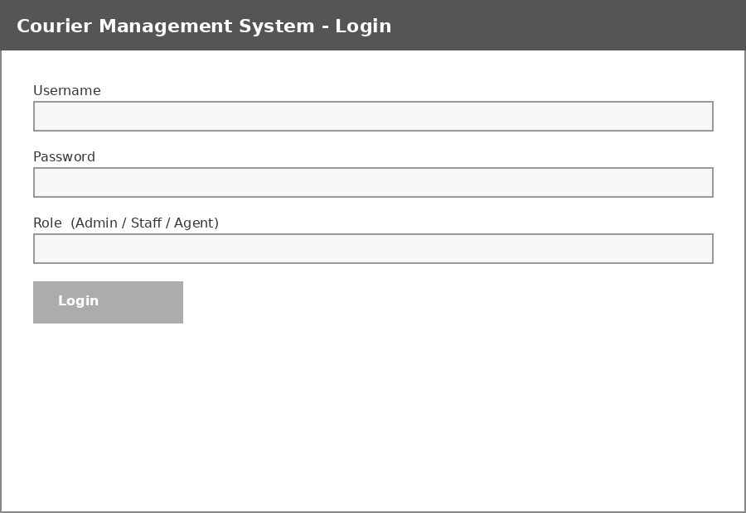
Figure 10.1: Login Screen
A single login screen is shared by Admin, Staff and Delivery Agent users; the role associated with the account determines which menu options are shown after login. Customers do not log in at all, consistent with the design decision explained in Section 8.4.

10.2 New Parcel Booking Screen
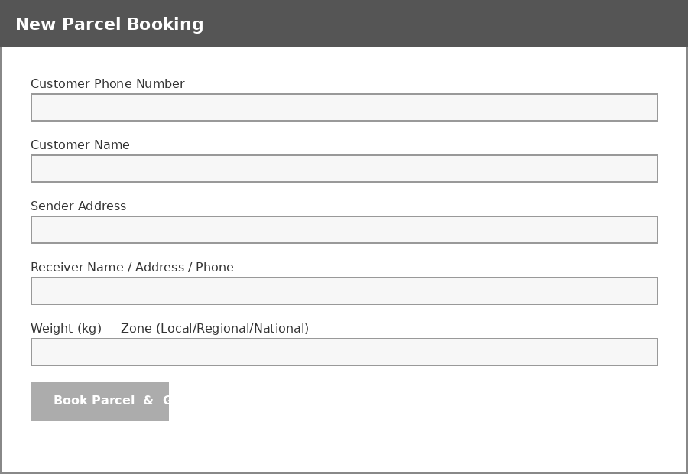
Figure 10.2: New Parcel Booking Screen
This is the primary screen used by front-desk staff. Submitting the form triggers the bookParcel() workflow described in Section 9.4, which generates the tracking number, calculates the charge, and produces the invoice in a single transaction.

10.3 Customer Tracking Screen
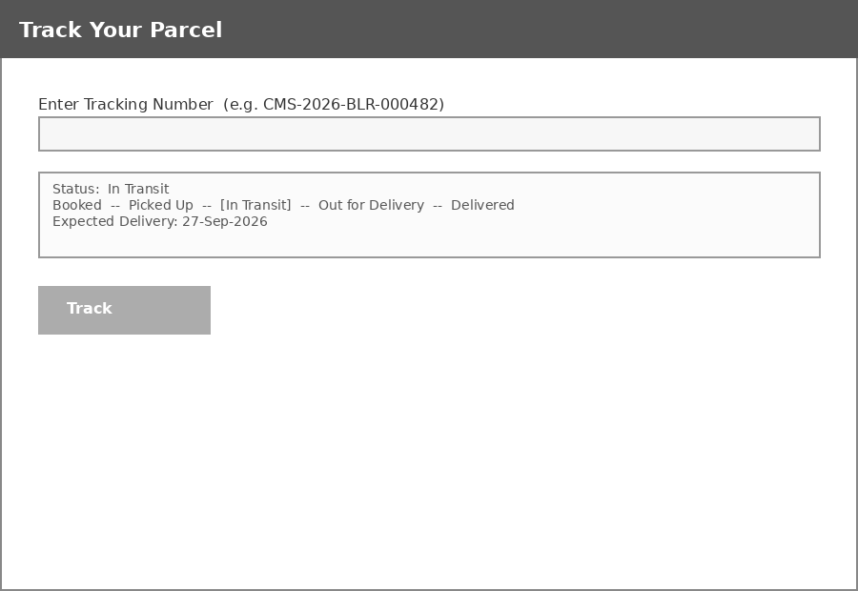
Figure 10.3: Customer Tracking Screen
The tracking screen shows a simplified progress indicator so that a customer can see at a glance both the current status and how much further the parcel has to travel through its lifecycle.

10.4 Delivery Agent Screen
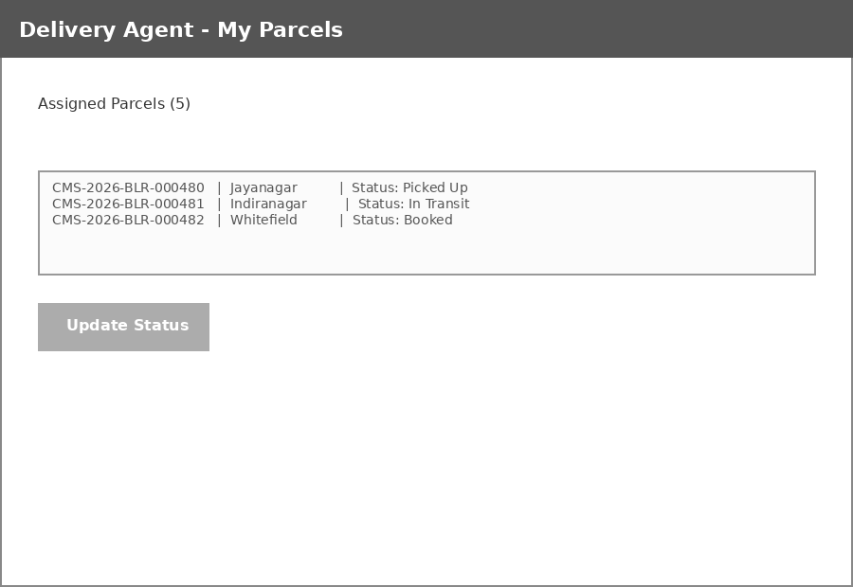
Figure 10.4: Delivery Agent - My Parcels Screen
Each agent sees only the parcels currently assigned to them, keeping the screen focused and reducing the chance of updating the wrong parcel, as discussed in Section 8.3.

10.5 Admin Dashboard
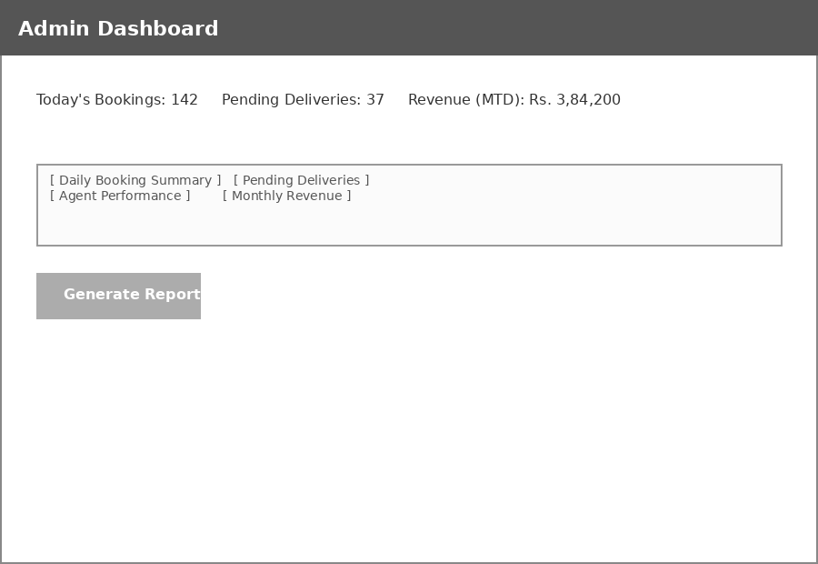
Figure 10.5: Admin Dashboard
The dashboard gives the administrator an at-a-glance summary of the day's activity, along with quick links to each of the four report types described in Section 8.6.

10.6 Invoice / Receipt
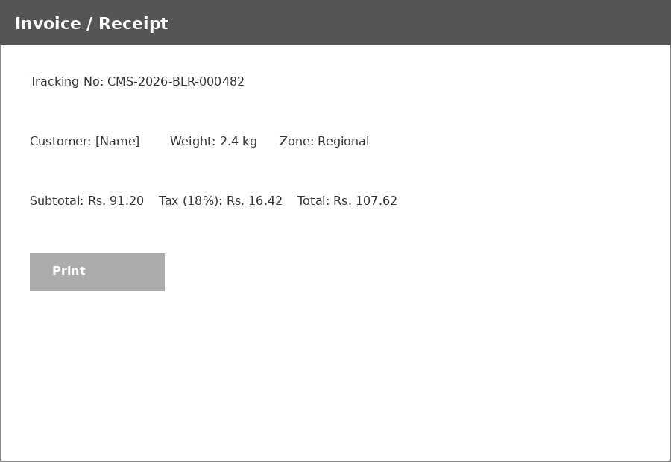
Figure 10.6: Invoice / Receipt
The invoice reflects the subtotal, tax and total exactly as computed by the calculateCharge() function shown in Section 8.2, ensuring that what the customer is shown always matches what was actually charged.

11. TESTING
Testing was carried out to ensure the system works correctly and reliably before deployment. Testing followed a bottom-up strategy: individual functions were tested first (unit testing), followed by verification that modules work correctly together (integration testing), followed by testing of the complete system against the functional requirements listed in Section 5.3 (system testing), and finally testing with representative end-users (user acceptance testing).

11.1 Testing Levels
Test Type | Description
Unit Testing | Each function (tracking number generation, charge calculation, status-transition validation) was tested individually against a range of valid and invalid inputs.
Integration Testing | Verified that modules work correctly together - e.g., that data entered during booking flows correctly into the billing and reporting modules.
System Testing | The complete system was tested against the functional requirements listed in Section 5.3, end to end.
User Acceptance Testing | Tested with sample data by end-users (staff) to confirm usability and that the workflow matched their expectations from the manual process.
Regression Testing | Re-ran the existing test cases after each significant change (e.g., adding the Invoice table) to confirm that previously working functionality was not broken.

11.2 Test Case Summary
The table below lists a representative sample of the test cases executed against the system, covering both normal (positive) and boundary/negative scenarios for the core modules.
TC ID | Module | Test Description | Input | Expected Result | Status
TC-01 | Booking | Book a valid parcel with all mandatory fields filled | Weight=2.5, Zone=Regional, valid addresses | Parcel created, tracking number generated, invoice shown | Pass
TC-02 | Booking | Attempt to book with weight left blank | Weight = (empty) | Validation error: “Weight is required”; record not saved | Pass
TC-03 | Booking | Attempt to book with negative weight | Weight = -3 | Validation error: “Weight must be positive” | Pass
TC-04 | Tracking No. | Generate two tracking numbers in the same branch/year | 2 consecutive bookings, same branch | Sequence numbers differ and are both unique | Pass
TC-05 | Billing | Calculate charge for 0.8 kg, Local zone | Weight=0.8, Zone=Local | Charge = base rate only (no extra-weight charge) | Pass
TC-06 | Billing | Calculate charge for 3.5 kg, National zone | Weight=3.5, Zone=National | Charge = base + (2.5 x per-kg rate), plus 18% tax | Pass
TC-07 | Status Update | Agent moves status forward (Booked to Picked Up) | Current=Booked, New=Picked Up | Status updated, Last_Updated timestamp refreshed | Pass
TC-08 | Status Update | Agent attempts to move status backward (Delivered to In Transit) | Current=Delivered, New=In Transit | Rejected with error: “Cannot move status backwards” | Pass
TC-09 | Customer Tracking | Look up a valid tracking number | Valid Tracking_No | Current status, booking date and expected delivery date shown | Pass
TC-10 | Customer Tracking | Look up a non-existent tracking number | Invalid Tracking_No | “Parcel not found” message shown; no system error | Pass
TC-11 | Reporting | Generate monthly revenue report for current month | Month = current | Revenue grouped by branch and payment mode, totals correct | Pass
TC-12 | Reporting | Generate pending-deliveries report when no parcels are pending | No pending records | Empty report shown with a clear “no pending deliveries” message, not an error | Pass
TC-13 | Login | Log in with correct staff credentials | Valid username/password | Redirected to Staff dashboard | Pass
TC-14 | Login | Log in with incorrect password | Valid username, wrong password | “Invalid credentials” message; no account lockout details revealed | Pass
TC-15 | Database Integrity | Attempt to delete a Branch that has active agents/parcels | DELETE on referenced Branch_ID | Operation rejected due to foreign-key (ON DELETE RESTRICT) constraint | Pass

11.3 Defects Identified and Resolved
During integration testing, two notable issues were identified and resolved prior to system testing:
- An early version of the tracking-number generator did not scope the per-branch sequence by year, which meant that a branch's counter would keep growing indefinitely rather than resetting each year as intended in the CMS-YYYY-BRC-NNNNNN format; this was corrected by adding a YEAR(Booking_Date) condition to the sequence-lookup query shown in Section 9.5.
- The initial status-update logic compared status strings alphabetically rather than by their position in the defined lifecycle order, which incorrectly allowed “Delivered” to be treated as earlier than “In Transit”; this was corrected by comparing array index positions within an explicitly ordered status list, as shown in Section 9.6.

11.4 Test Environment
Testing was carried out on a local development environment (XAMPP stack: Apache, MySQL, PHP) running on the hardware and operating system configurations listed in Section 5.1, using a seeded test database populated with representative sample data (see Appendix B) covering multiple branches, agents and customers.

12. SYSTEM SECURITY
Because the Courier Management System stores personally identifiable customer information and handles financial transactions, security was treated as a first-class design concern rather than an afterthought. The following measures are built into the design and implementation described in earlier chapters.

12.1 Authentication and Authorisation
- Staff, Agent and Admin users must log in with a username and password before accessing any function of the system; Customers are deliberately not required to log in (Section 8.4), and are correspondingly given access only to read-only status information keyed by tracking number, never to any other customer's data.
- Passwords are never stored in plain text; the Staff table (Section 7.6) stores only a salted hash (e.g. using bcrypt), so that even a database breach does not directly expose usable passwords.
- Role-based access control (Admin / Staff / Agent) restricts each user to the functions appropriate to their role - for instance, only Admin accounts can access the Branch/Agent management screens.

12.2 Protection Against SQL Injection
All database queries that include user-supplied input use parameterised (prepared) statements, as shown throughout the code samples in Chapter 9 and Appendix A, rather than concatenating user input directly into SQL strings. This prevents a malicious user from injecting SQL commands through, for example, the tracking-number lookup field.

12.3 Input Validation
Every form is validated both on the client side (for immediate feedback) and, more importantly, on the server side (as the authoritative check). Server-side validation cannot be bypassed by disabling JavaScript or crafting a direct HTTP request, unlike client-side validation alone.

12.4 Data Integrity and Backup
- Foreign-key constraints (Section 7.10) prevent orphaned or inconsistent records at the database level.
- Booking operations that touch multiple tables (Parcel, Payment, Invoice) are wrapped in database transactions (Section 9.4), ensuring that a failure partway through does not leave the database in an inconsistent state.
- Regular, scheduled database backups are recommended (daily, at minimum) so that records can be restored in the event of hardware failure or accidental data loss.

12.5 Privacy Considerations
The customer-facing tracking screen (Section 8.4, Section 10.3) intentionally omits sensitive details such as full sender/receiver addresses, showing only status and dates. This limits the information exposed if a tracking number is guessed or shared, since a tracking number alone reveals only shipment progress, not personal address information.

13. COST ESTIMATION
A simplified, effort-based cost estimate is presented here using a Function Point-style approach appropriate for an academic project of this scope. This estimate is intended to demonstrate the process of cost estimation rather than to represent a binding commercial quotation.

13.1 Effort Estimation
Module | Estimated Effort (person-days)
Database design and setup | 3
Admin module (branch/agent management, reports) | 5
Booking module (customer registration, booking, invoicing) | 6
Tracking module (agent status update, customer lookup) | 4
Billing module (charge calculation, payment recording) | 3
Reporting module (4 report types) | 4
UI design and integration across modules | 5
Testing (unit, integration, system, UAT) | 5
Documentation | 3
Total | 38

13.2 Cost Estimation
Using an illustrative effort rate (which would be substituted with an actual, locally applicable rate in a real commercial estimate), the total development cost can be estimated as: Total Effort (38 person-days) x Rate per person-day. Since all core software components used (PHP, MySQL, Apache) are free and open-source, the dominant cost driver is development effort rather than software licensing, which keeps this project considerably cheaper to develop than a system built on proprietary, license-fee-based platforms.

13.3 Return on Investment
On the benefit side, the system is expected to reduce staff time currently spent on manual billing calculation and end-of-day/month report compilation (Chapter 2), and to reduce revenue leakage from billing errors. For an organisation processing even a moderate daily parcel volume, the time saved in daily operations is expected to offset the one-time development effort within a relatively short period, making the project a favourable investment; a precise payback period would depend on the specific organisation's current parcel volume and staff costs, which are outside the scope of this academic report.

14. FUTURE ENHANCEMENTS
While the current design fulfils the core objectives set out in Chapter 1, several enhancements were identified during the course of this project that would extend its capability and are natural next steps for future work:
- SMS / Email Notifications: The Notification table (Section 7.8) already logs every status-change event; the natural next step is to connect this log to an SMS or email gateway so that customers are proactively informed of status changes rather than needing to check the tracking screen themselves.
- Online Payment Gateway Integration: Currently, the Payment table records the payment mode after the fact; integrating a payment gateway (e.g. for card or UPI payments) would allow customers to pay for a booking online and have the Payment_Status field updated automatically via a callback/webhook.
- Dedicated Mobile Application: A native or cross-platform mobile app for customers (to track parcels) and for delivery agents (to update status on the move, potentially with offline support that syncs once connectivity is restored) would improve the experience for both groups compared to a browser-based interface.
- GPS-Based Live Tracking of Delivery Vehicles: Extending the Delivery_Agent and Parcel tables with live location data (captured from a mobile app) would allow the customer tracking screen to show not just a status label but an actual map view of the parcel's current location, similar to ride-hailing applications.
- AI-Based Route Optimisation: Once sufficient historical delivery data has accumulated in the Parcel table, a route-optimisation algorithm could suggest an efficient delivery sequence for each agent's assigned parcels, reducing delivery time and fuel cost.
- Customer Self-Service Portal with Login: While the current design deliberately avoids requiring customer login (Section 8.4) to keep the tracking experience frictionless, an optional account-based portal could be added for repeat/corporate customers who want to view their full booking history, download past invoices, and manage saved addresses.
- Multi-Language Support: Adding localisation to the interface would make the system usable by staff and customers who are more comfortable in a regional language.
These enhancements were deliberately kept out of the current scope (Section 1.2) so that the core system could be completed, tested and documented within the project timeline, while the architecture (Chapter 6) was designed specifically so that none of these additions would require restructuring the existing database schema or application layers.

15. CONCLUSION
The Courier Management System successfully automates the core operations of a courier business - booking, tracking, delivery status updates and billing - replacing an error-prone manual process with a fast, reliable and centralised digital system. Through the analysis presented in this report, the limitations of the existing manual system (Chapter 2) were identified and directly addressed by the design of the proposed system (Chapter 3): a unique, system-generated tracking number replaces informal tracking, automatic charge calculation replaces manual billing, and on-demand reports replace tedious end-of-period manual compilation.
The system's three-tier architecture (Chapter 6), normalised database schema (Chapter 7) and clearly separated modules (Chapter 8) give it a solid technical foundation that is both maintainable and extensible. The testing carried out (Chapter 11) - covering unit, integration, system and user-acceptance levels - gives reasonable confidence that the system behaves correctly across both normal and boundary-case scenarios, including the two defects identified and resolved during integration testing.
More broadly, this project demonstrates the practical application of software engineering principles - requirement analysis, feasibility study, structured design (DFDs, ER modelling, use case analysis), normalised database design, modular implementation and systematic testing - to a real-world business problem. It improves operational efficiency, reduces manual workload, and enhances the overall customer experience through real-time parcel tracking. The modular design also makes the system easy to extend with additional features such as online payments, SMS notifications and mobile tracking, as discussed in Chapter 14, positioning it as a practical and scalable foundation for a real courier or logistics operation.

16. BIBLIOGRAPHY / REFERENCES
Elmasri, R. & Navathe, S. — Fundamentals of Database Systems.
Sommerville, I. — Software Engineering.
Pressman, R. S. — Software Engineering: A Practitioner's Approach.
Silberschatz, A., Korth, H. F. & Sudarshan, S. — Database System Concepts.
Official documentation of the programming language / framework used (e.g. PHP Manual, php.net).
Official documentation of the DBMS used (MySQL Reference Manual, dev.mysql.com).
Official documentation for the web server used (Apache HTTP Server documentation, httpd.apache.org).
W3Schools / GeeksforGeeks — for syntax reference and implementation examples.
OWASP Foundation — guidance on SQL injection prevention and secure coding practices, referenced in Chapter 12.
Unified Modeling Language (UML) specification, Object Management Group (OMG) — for use case and class diagram notation used in Chapter 6.

APPENDIX A: SAMPLE SOURCE CODE
This appendix contains additional representative source code that complements the excerpts already shown in Chapter 9, covering customer registration and the pending-deliveries report query.

A.1 Customer Registration / Lookup
<?php
function findOrCreateCustomer($conn, $phone, $name, $address, $email) {
$stmt = $conn->prepare("SELECT Customer_ID FROM Customer WHERE Phone = ?");
$stmt->bind_param("s", $phone);
$stmt->execute();
$result = $stmt->get_result();
if ($row = $result->fetch_assoc()) {
return $row['Customer_ID']; // existing customer found
}
$insert = $conn->prepare(
"INSERT INTO Customer (Name, Address, Phone, Email) VALUES (?,?,?,?)"
);
$insert->bind_param("ssss", $name, $address, $phone, $email);
$insert->execute();
return $conn->insert_id; // new customer created
}
?>

A.2 Pending Deliveries Report Query
SELECT
b.Branch_Name,
pc.Tracking_No,
pc.Status,
DATEDIFF(CURDATE(), pc.Booking_Date) AS Days_Pending
FROM Parcel pc
JOIN Branch b ON pc.Branch_ID = b.Branch_ID
WHERE pc.Status <> 'Delivered'
ORDER BY Days_Pending DESC;

A.3 Agent-Wise Performance Report Query
SELECT
da.Name AS Agent_Name,
b.Branch_Name,
da.Parcels_Delivered,
COUNT(pc.Tracking_No) AS Currently_Assigned
FROM Delivery_Agent da
JOIN Branch b ON da.Branch_ID = b.Branch_ID
LEFT JOIN Parcel pc ON pc.Agent_ID = da.Agent_ID AND pc.Status <> 'Delivered'
GROUP BY da.Agent_ID
ORDER BY da.Parcels_Delivered DESC;

A.4 Client-Side Validation (Booking Form)
function validateBookingForm() {
const weight = parseFloat(document.getElementById('weight').value);
const phone = document.getElementById('receiverPhone').value;
if (isNaN(weight) || weight <= 0) {
showError('Weight must be a positive number.');
return false;
}
if (!/^\d{10}$/.test(phone)) {
showError('Receiver phone must be a 10-digit number.');
return false;
}
return true; // server-side validation still runs as the authoritative check
}

APPENDIX B: SAMPLE TEST DATA
The following sample records were used to seed the test database referred to in Section 11.4.

B.1 Sample Branch Records
Branch_ID | Branch_Name | Location
1 | Jayanagar Branch | Bengaluru
2 | Indiranagar Branch | Bengaluru
3 | Whitefield Branch | Bengaluru

B.2 Sample Customer Records
Customer_ID | Name | Phone
101 | A. Ramesh | 9876543210
102 | P. Lakshmi | 9876501234
103 | S. Karthik | 9123456780

B.3 Sample Parcel Records
Tracking_No | Customer_ID | Weight | Zone | Status
CMS-2026-JYN-000001 | 101 | 1.2 | Local | Delivered
CMS-2026-IND-000001 | 102 | 3.5 | Regional | In Transit
CMS-2026-WFD-000001 | 103 | 0.6 | National | Booked
The complete seed script also populates sample Delivery_Agent, Payment, Invoice and Staff records covering all three branches, used consistently throughout the test cases documented in Section 11.2.

